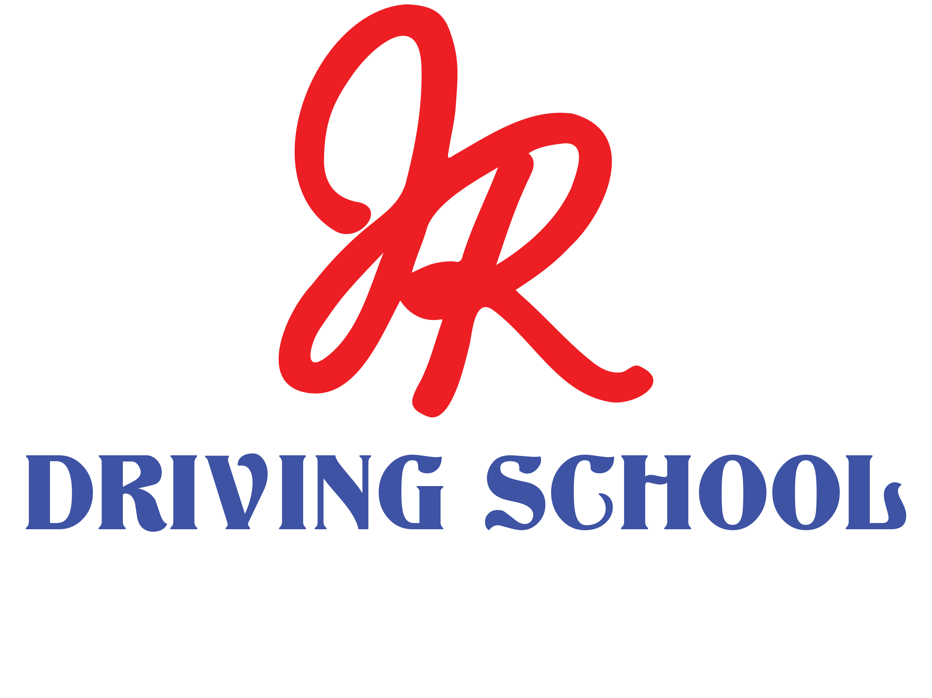
DEFENSIVE DRIVING — QUICK QUIZ
The LLLC System • 20 Questions

Name: ____________________________ | Date: ______________ | Score: _______ / 20
Instructions: Read each question and circle the letter of the best answer. Then write that letter on the line at the right. There is one best answer per question.

1. What does “LLLC” stand for? | ____
A. Look, Listen, Learn, Care
B. Look Ahead, Look Around, Leave Room, Communicate
C. Lights, Lanes, Limits, Caution

2. How many seconds ahead should you look down the road? | ____
A. 3 seconds
B. 15 seconds
C. 60 seconds

3. What is the smallest safe following distance in good weather? | ____
A. 1 second
B. 3 seconds
C. Half a second

4. If it starts to rain, you should leave… | ____
A. More space
B. Less space
C. The same space
5. Before you change lanes, you should check your… | ____
A. Radio
B. Blind spot
C. Phone
6. How often should you glance at your mirrors? | ____
A. Every 5–8 seconds
B. Once a trip
C. Only when parking

7. A green light always means it's safe to go. | ____
A. True
B. False

8. Is it OK to send a quick text if you're a fast driver? | ____
A. Yes
B. No

9. At the very top of the safety triangle is… | ____
A. 300 risky habits
B. 1 major crash
C. 29 small crashes

10. In the 300:29:1 safety theory, what does the big number 300 stand for? | ____
A. 300 major crashes
B. 300 small risky habits & near-misses
C. 300 miles driven

11. When should you turn on your blinker? | ____
A. As you turn
B. Early, before you turn
C. After you turn

12. A car is tailgating you. Should you brake-check them? | ____
A. Yes, teach them a lesson
B. No, leave more room in front

13. Should you make eye contact with people crossing the street? | ____
A. Yes
B. No

14. At 60 mph, how far does your car travel each second? | ____
A. About 10 feet
B. About 88 feet
C. About 5 feet

15. Is it good to stare at one spot for a long time while driving? | ____
A. Yes
B. No, keep your eyes moving

16. How many sides of your car should you keep space on? | ____
A. Just the front
B. All six sides
C. Only the back

17. When stopped behind a car, you should be able to see its… | ____
A. Back tires touching the road
B. License plate letters
C. Back seat

18. At an intersection, you should look… | ____
A. Straight only
B. Left, Right, then Left again
C. Down at the dash

19. What's the best way to handle the “I always do it and I'm fine” feeling? | ____
A. Trust your luck
B. Drop the risky habit anyway

20. Why do we drive defensively? | ____
A. To go faster
B. To protect yourself and everyone around you
C. To save gas

